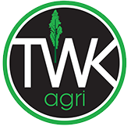

TWK Agri found the engagement with Eberhard Niklaus from The Strengths Toolbox to be highly valuable and professionally delivered. His strengths-based approach translated complex concepts into practical, actionable insights that enhanced team collaboration, leadership understanding, and performance. The session was engaging, relevant across roles, and supported both individual growth and organisational effectiveness.

Louise Johnson
Manager: Corporate Marketing and Communication
082 322 1844
017 824 1038
ljohnson@twkagri.com
101 Voortrekker Street, Greytown, 2380
www.twkagri.com

